📄 Requirements Gathering Document

Project: Digital Library Management System
1. Introduction
Requirements gathering is the foundation of successful software development. For the Digital Library Management System, requirements are collected using three complementary approaches: Traditional Requirements, Use Cases, and User Stories. To ensure proper tracking and collaboration, project management tools such as Jira and Trello will be used throughout the process.

2. Traditional Requirements
Functional Requirements
- The system shall allow users (students/faculty) to register and log in.
- The system shall enable librarians to add, edit, and delete book records.
- The system shall allow users to search books by title, author, or category.
- The system shall manage borrowing and returning of books.
- The system shall generate reports of borrowed and available books.
Non-Functional Requirements
- The system shall be accessible via standard web browsers.
- The system shall support up to 200 concurrent users.
- The system shall provide response times under 3 seconds for search operations.
- The system shall ensure secure authentication and protect user data.
- The system shall maintain availability of 99% during working hours.

3. Use Case Modelling
Use Case 1: Search Book
- Actors: Registered User
- Precondition: User is logged in.
- Steps:
  - User enters search criteria (title/author).
  - System retrieves matching records.
  - System displays results with availability status.
- Postcondition: User views book details.
Use Case 2: Borrow Book
- Actors: Registered User, Librarian
- Precondition: Book is available.
- Steps:
  - User requests to borrow a book.
  - Librarian confirms availability.
  - System updates book status to “Borrowed.”
- Postcondition: Book is marked as borrowed under user’s account.

4. User Stories
- Story 1: As a student, I want to search for books by title so that I can quickly find references.
- Story 2: As a faculty member, I want to borrow books online so that I can save time.
- Story 3: As a librarian, I want to manage book records so that the catalog stays updated.
- Story 4: As a user, I want to see the availability status so that I know if a book can be borrowed.
- Story 5: As an administrator, I want to generate reports so that I can monitor library usage.

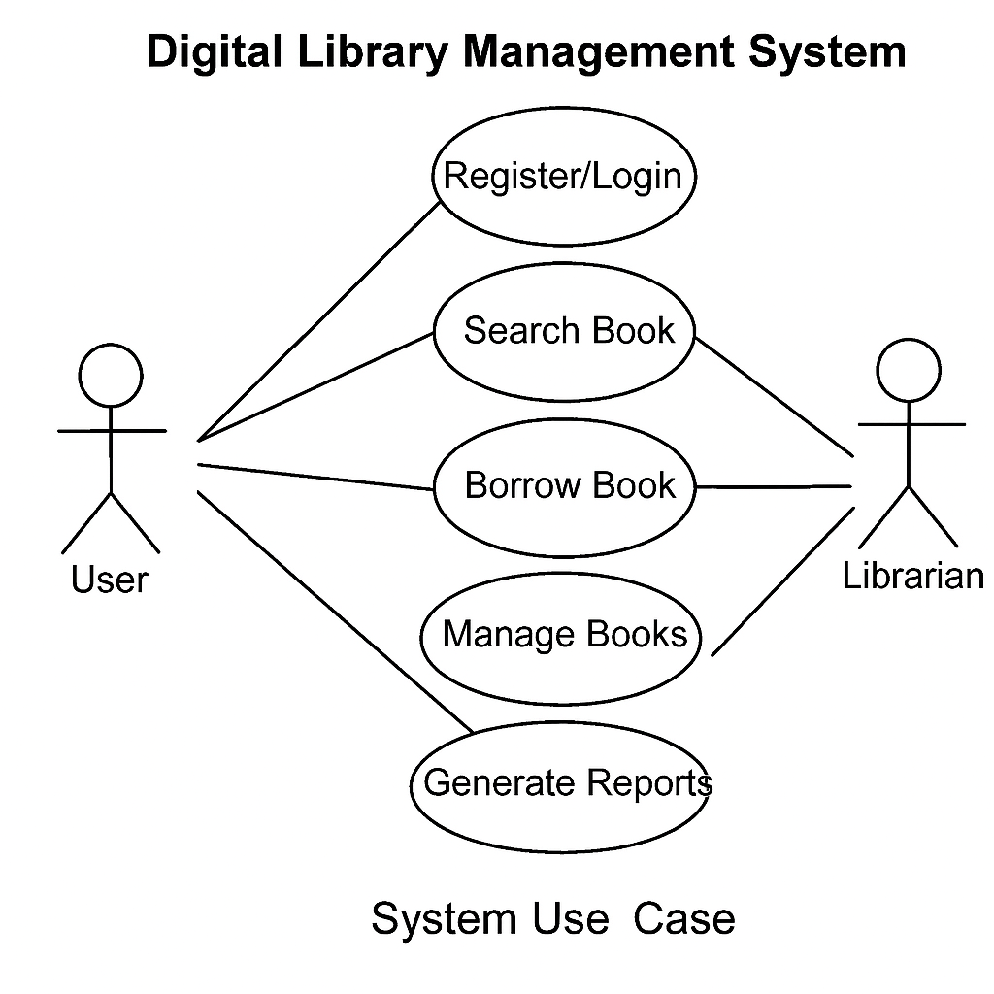

5. Requirements Tracking with Jira
- Jira:
  - Each requirement is created as an “Issue.”
  - User Stories are grouped under Epics (e.g., “Book Management”).
  - Workflow states (To Do, In Progress, Done) track progress.
  - Dashboards provide visibility into.

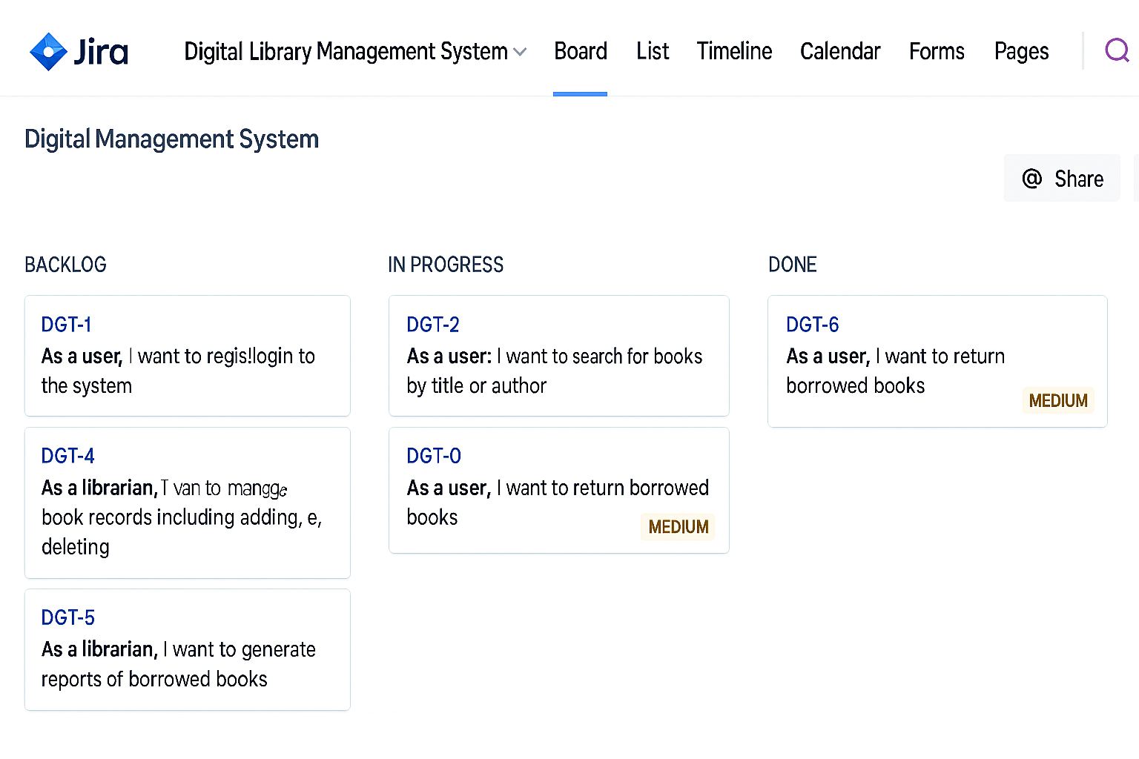
6. Conclusion
By combining Traditional Requirements, Use Cases, and User Stories, the Digital Library Management System ensures clarity and completeness in requirement gathering. Using Jira and Trello provides transparency, accountability, and efficient tracking of requirements throughout the development lifecycle.

